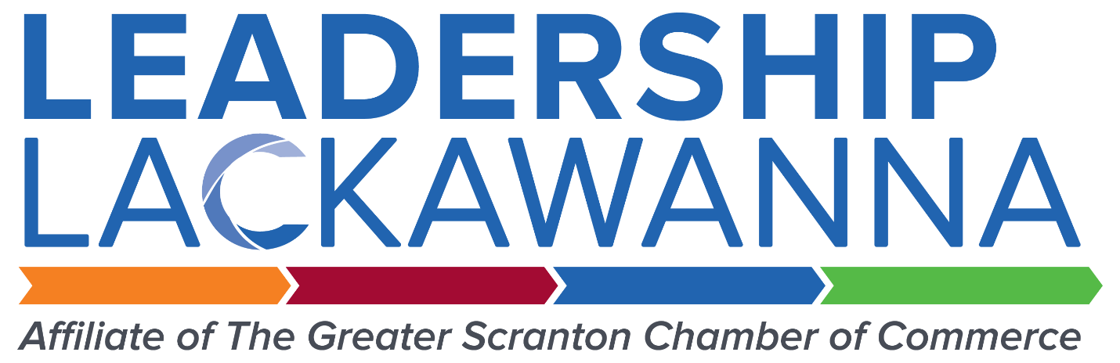

Leadership Lackawanna
Style & Brand Guide

prepared by The Staff of Leadership Lackawanna

In order to maintain a strong and consistent visual identity, this guide has been created to provide pertinent information on logos, typography, and colors that make up the Leadership Lackawanna brand identity. The following is a list of guidelines to be used for all copy regarding Leadership Lackawanna, its programs, events and alumni. Use of these guidelines will ensure that there is a consistent presentation of content. This content is based off the 2017 guidelines of the Associated Press Stylebook. For questions not answered in this document, please refer to the AP Stylebook.

Leadership Lackawanna
The name of our organization is “Leadership Lackawanna”. Both “Leadership” and “Lackawanna” are always capitalized.

Courtesy Titles
Professional titles are not capitalized when following the persons name – for example, “Nicole Morristell, executive director of Leadership Lackawanna.” When used ahead of the person’s name, professional titles are capitalized – for example, “Executive Director Nicole Morristell”.

Noting Time of Day
When listing the time of an event, use a.m. and p.m., unless in advertising content, where AM and PM are permissible. Also write the time of the event noting the hours and minutes of the event, unless it falls on the hour or at noon. When an event starts at noon, list the event starting time as “noon” instead of “12:00 PM.”

Dates
When listing the date of an event, always list the day and year. For example, use “Wednesday, August 28, 2019.”

Street Addresses
For published articles, defer to the AP Stylebook and use street abbreviations (St. Ave., etc.). For invitations on advertising content, spell out the type of roadway that is associated with an address. For example, use “222 Mulberry Street” instead of “222 Mulberry St.”’

Sponsor Logos
When requesting sponsor logos, they need to be requested at a minimum of 300 dpi and preferably in an eps format. LL staff can convert all .eps files into other extensions as needed (.pdf, .jpg., .png, etc.) If the sponsor logos are not received in the proper format this can cause major in delays in publication.

Names of Publications
The names of all Leadership and non-Leadership publications should be italicized. For example, italicize the Leadership Lackawanna Annual Report, Northeast Pennsylvania Business Journal and The Times-Tribune. If you are working on a platform where italicization is not possible, please use quotation marks.

Northeastern Pennsylvania vs. northeastern Pennsylvania
Always refer to “northeastern Pennsylvania.”

“Greater Scranton”
When discussing the region as a whole, use the “Greater Scranton Region” versus
“Greater Scranton” or “Greater Scranton Area”

Numbers and Symbols
Spell out numbers one through nine, and figures can be used for numbers 10 and higher. Spell out simple fractions and use hyphens with them. For example, use “one-half” instead of ½. With numbers of four or more digits, use commas. When using percentage in written publications, use the word “percent” versus %, Defer to the business name if an ampersand or other symbol is used – for example POSH @ The Scranton Club.

Use vs. Utilize
Utilize is only to be used in scientific writing.

Company Names
Defer to how the business writes its name – for example, “the” in The University of Scranton is capitalized, regardless of AP style rules.

Apostrophes
Apostrophes are used for possession only – never to denote a plural case.
Understanding File Formats
EPS- This is a ‘high resolution vector file format. EPS is the preferred format by most printers and designers but may not open in all regular review programs.
PDF- One of the most common file formats that can be opened in acrobat reader and most web browsers. This format is high resolution and can be used in print.
PNG- This is the best format for web and screen resolution. This format also has a transparent background.
JPG- This is one of the most common file formats and can function in both screen and print.

Primary Logo: Full Color
This version of the logo is recommended
for use whenever possible.

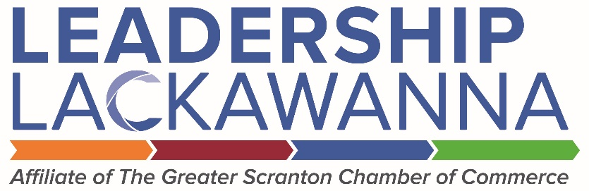

Primary Logo: No Tagline
This version is recommended for use where Leader’s chamber affiliation is clearly established.

Primary Logo: Minimum Size
For legibility purposes, the primary logo
should never be smaller than 1.25” wide.

.41”

1.25”

Primary Logo: Clear Space
25% of the logo width should be left on all sides.

Primary Logo: One Color
For use when color printing is not an option, as in faxing or photocopying.

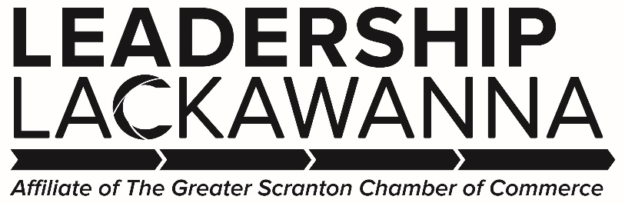

Primary Logo: One Color, No Tagline
This version is recommended for use where Leader’s chamber affiliation is clearly established. Also for use when color printing is not an option.

Logo Color: Logo colors should always remain consistent and never change according to application.

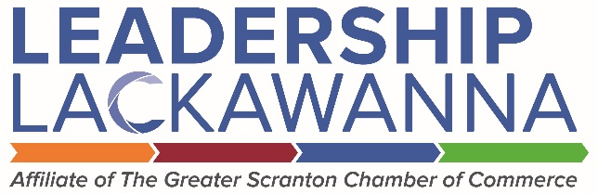

Logo: Scaled and Sized
The logo should always be proportionately scaled and sized, never stretched or distorted.
The Leadership brand uses grey or white lettering accented by bright colors. The letters in the logo should not appear in any color other than black, white or gray. Accent colors should be used together in the logo or individually to indicate programs of Leadership Lackawanna.

Primary Colors
White

c 0 m 0 y 0 k 0
r 255 g 255 b 255
HTML FFFFFF

Pantone Cool Gray 10

c 40 m 30 y 20 k 66
r 99 g 102 b 106
HTML 63666A

Accent Colors

Pantone 7684

c 90 m 64 y 0 k 0
r 56 g 95 b 157
HTML/Hex 385E9D
Pantone 369

c 68 m 0 y 100 k 0
r 100 g 167 b 11
HTML/Hex 64A70B
Pantone 716

c 0 m 61 y 99 k 0
r 234 g 118 b 0
HTML/HEX EA7600
Pantone 201

c 7 m 100 y 68 k 32
r 157 g 34 b 53
HTML/HEX 9D2235

Brand fonts should be clean sans serif typefaces. When possible use the Avenir font family.
Avenir Light
Aa Bb Cc Dd Ee Ff Gg Hh Ii Jj Kk Ll Mm Nn Oo Pp Qq Rr Ss Tt Uu Vv Ww Xx Yy Zz
0 1 2 3 4 5 6 7 8 9
Avenir Book
Aa Bb Cc Dd Ee Ff Gg Hh Ii Jj Kk Ll Mm Nn Oo Pp Qq Rr Ss Tt Uu Vv Ww Xx Yy Zz
0 1 2 3 4 5 6 7 8 9
Avenir Medium
Aa Bb Cc Dd Ee Ff Gg Hh Ii Jj Kk Ll Mm Nn Oo Pp Qq Rr Ss Tt Uu Vv Ww Xx Yy Zz
0 1 2 3 4 5 6 7 8 9
Avenir Heavy
Aa Bb Cc Dd Ee Ff Gg Hh Ii Jj Kk Ll Mm Nn Oo Pp Qq Rr Ss Tt Uu Vv Ww Xx Yy Zz
0 1 2 3 4 5 6 7

